Problem 1

A public library keeps the following table of data about its patrons:

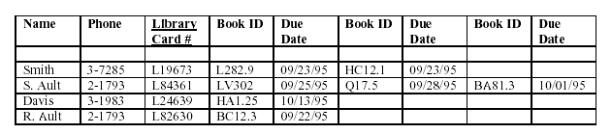

Which normal forms are violated?

Identify Anomalies in the database?